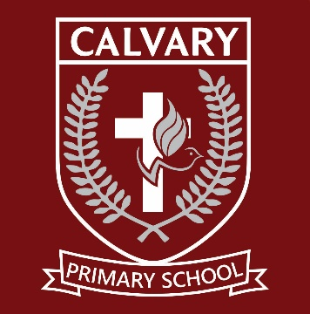
CALVARY CHRISTIAN COLLEGE
2027
PRIMARY SCHOOL FEE SCHEDULE
Parents are required to follow the application process as set out on the school website or visit the school reception for further information regarding admissions and enrolment procedures. Submission of an application does not guarantee placement, and all fees listed are subject to the school's terms and conditions.
Calvary Christian College remains one of the most affordable private schools in the South of Johannesburg.
ONCE-OFF NON REFUNDABLE FEES
Item Fee | Amount
Placement Assessment Fee | R 200
Application Fee | R 500
Development Fund (Non-refundable) | R3,000
ANNUAL SCHOOL FEES
Grade | Annual Fee | Monthly Fee (11 Months)
Grade R | R41,734.00 | R3,794.00
Grade 1 | R45,122.00 | R4,102.00
Grade 2 | R46,926.88 | R4,266.08
Grade 3 | R50,496.16 | R4,590.56
Grade 4 | R54,774.72 | R4,979.52
Grade 5 | R54,877.68 | R4,988.88
Grade 6 | R57,325.84 | R5,211.44
Grade 7 | R57,428.80 | R5,220.80
EARLY SETTLEMENT DISCOUNT
- A 7% discount is available if the full annual fee is paid by 31 January 2027.
SIBLING DISCOUNTS
- Sibling discounts are available upon request.

INCLUDED IN SCHOOL FEES
- Swimming (Grades R–3)
- Support classes: English, Afrikaans, and Mathematics
- Robotics (Grades R–3)
- EdShed Phonics Programme (Grades R–3)
- IT (Grades 4–7)
ADDITIONAL COSTS (NOT INCLUDED)
- Excursions
- Special camps
- Social events (fundraisers, outreach, etc.)
- Diaries (Primary School only)
- Lockers
- Stationery
- Workbooks/Textbooks
- Maths4Me (Grades 1–7)
- IEB assessments (Grade 3 at a reduced rate)
- International Benchmark (Grade 7)
PAYMENT TERMS
- Grades R–7: Payable monthly in advance over 11 months (January–November)

